**Exercise 3: Assertions in Junit**

**Code:**

**AssertionsTest.java**

package com.example.JUnitDemo;

import static org.junit.jupiter.api.Assertions.*assertEquals*;

import static org.junit.jupiter.api.Assertions.*assertFalse*;

import static org.junit.jupiter.api.Assertions.*assertNotNull*;

import static org.junit.jupiter.api.Assertions.*assertNull*;

import static org.junit.jupiter.api.Assertions.*assertTrue*;

import org.junit.jupiter.api.Test;

public class AssertionsTest {

*@Test*

public void testAssertions() {

*assertEquals*(5, 2 + 3);

*assertTrue*(5 > 3);

*assertFalse*(5 < 3);

*assertNull*(null);

*assertNotNull*(new Object());

}

}

**Screenshot of JUnit panel:**

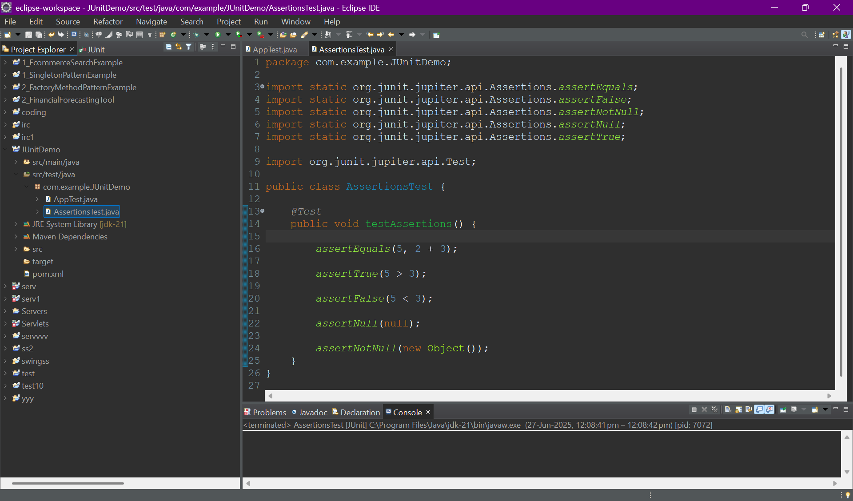

**Output:**

**Screenshot of JUnit panel:**

